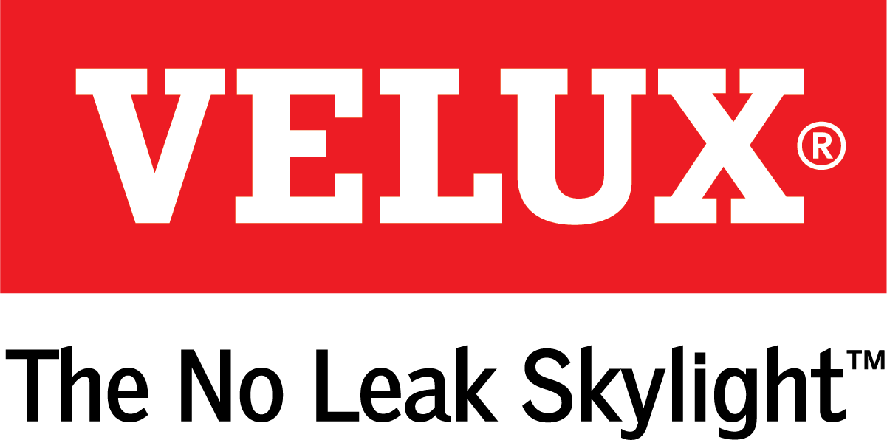
Media Contacts:
Kelsey Webb
704-790-1560
kwebb@wrayward.com

Dana Haydock
704-926-1301
dhaydock@wrayward.com

VELUX “GO SOLAR” PRODUCTS ARE A COST-EFFECTIVE OPTION
TO ADD NATURAL LIGHT TO HOMES
2019 is the Last Year to Claim the 30 Percent Federal Tax Credit on Solar Property

LAS VEGAS, Feb. 19-21, 2019 – VELUX is making it easier for homeowners to qualify for the full federal tax credit on solar property with its Go Solar program.
“VELUX encourages homeowners purchasing fixed and manual skylights to Go Solar by adding solar-powered blinds,” said Ross Vandermark, national product manager for VELUX America. “By taking this step and making their skylights and homes more energy efficient, homeowners can take advantage of the federal tax credit, saving themselves hundreds of dollars.”
The estimated cost to purchase and install a fixed skylight is $1,900. However, homeowners can Go Solar by adding a solar powered blind with a free VELUX ACTIVE Gateway to be eligible for a 30 percent federal tax credit on product and installation. With a total estimated tax credit of $685, the homeowner saves $300.
The VELUX ACTIVE Gateway allows the homeowner to operate their new solar blinds with the VELUX ACTIVE smartphone app.
VEUX Go Solar products include:
- Deck and curb mounted fixed skylights and flashing kit with solar powered blinds and a free VELUX ACTIVE Gateway
- Deck and curb mounted manual venting skylights and flashing kit with solar powered blinds and a free VELUX ACTIVE Gateway
- Rigid Sun Tunnel skylights with a solar powered night light
Go Solar products build on the VELUX solar powered product line, which includes No Leak Solar Powered Fresh Air Skylights (curb and deck mounted models).
This year is the last year to claim the full 30 percent federal tax credit available for solar product purchase and installation. Qualifying VELUX products purchased and installed by December 31, 2019 are eligible for the full 30 percent credit. The credit decreases to 26 percent in 2020 and 22 percent in 2021. For more information on how to claim the 30 percent tax credit before Dec. 31, 2019, visit veluxusa.com/help/tax-credit.

# # #

VELUX is the world leader in skylights and roof windows and is one of the strongest brands in the global building materials sector. VELUX America products are available nationwide through home centers, building material suppliers, lumberyards and independent door, window or roofing retailers. Consumers can locate local suppliers and installers and access information on skylight selection and the benefits of bringing more natural light and fresh air into the home by visiting www.veluxusa.com or www.whyskylights.com. VELUX skylights are made in America in Greenwood, South Carolina.

